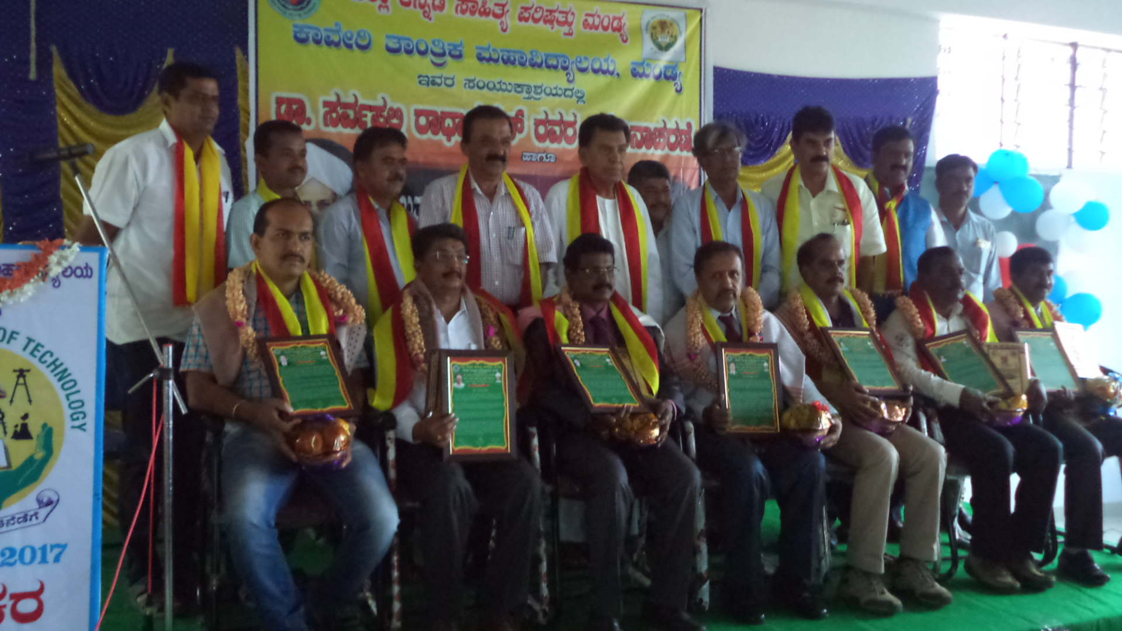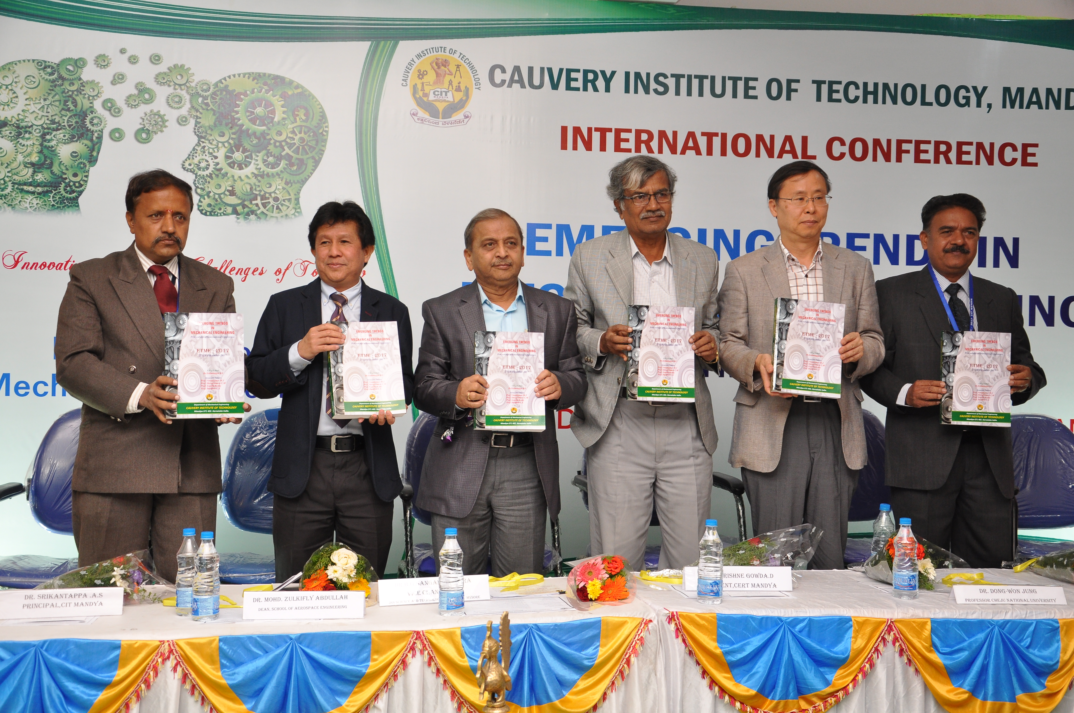
Mandya Kannada Sahithya Parishad, Felicitating Dr.Srikantappa A S Release of Proceedings during the inauguration of
for a “Best Teacher Award” “International Conference on ETME – 2017”
By Chief Guest Dr.B G Sangameshwara, Dr.Dong
Won Jung & Dr.Mohammed Zulkifly Abdullah

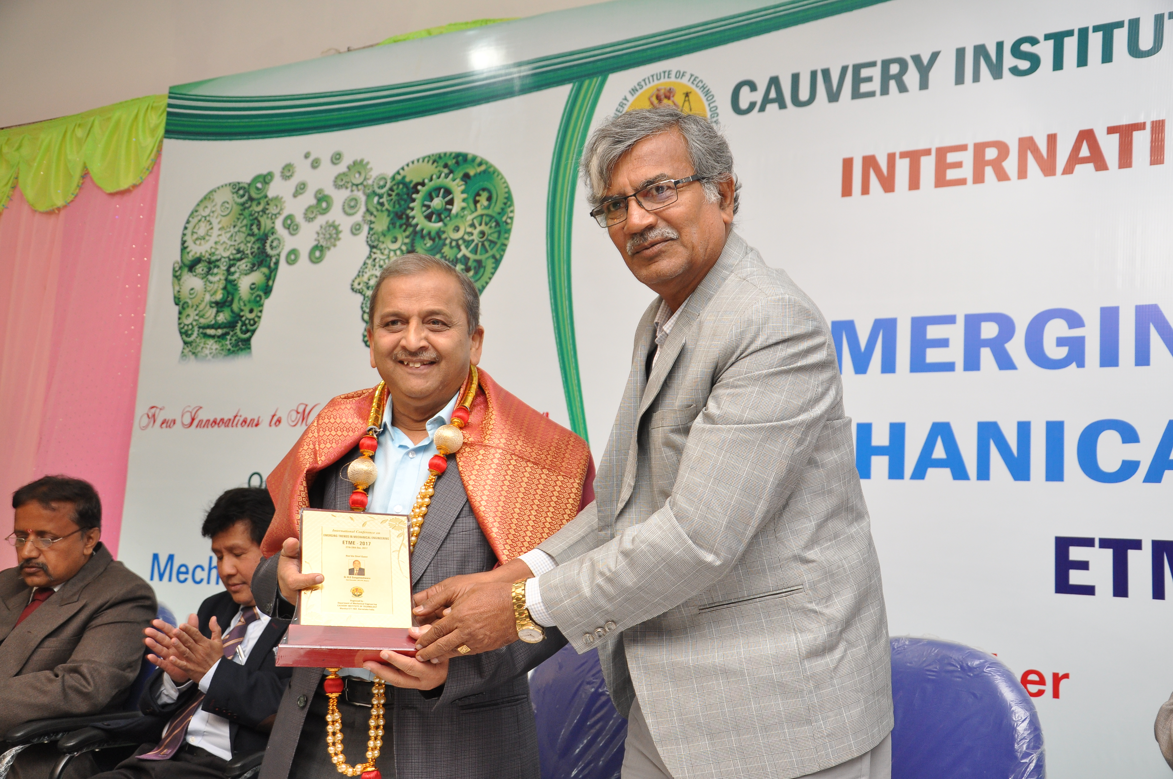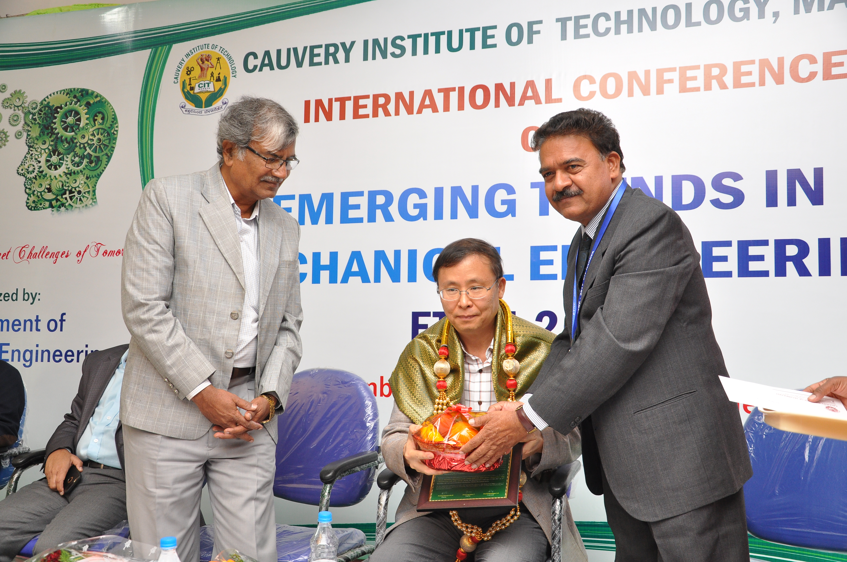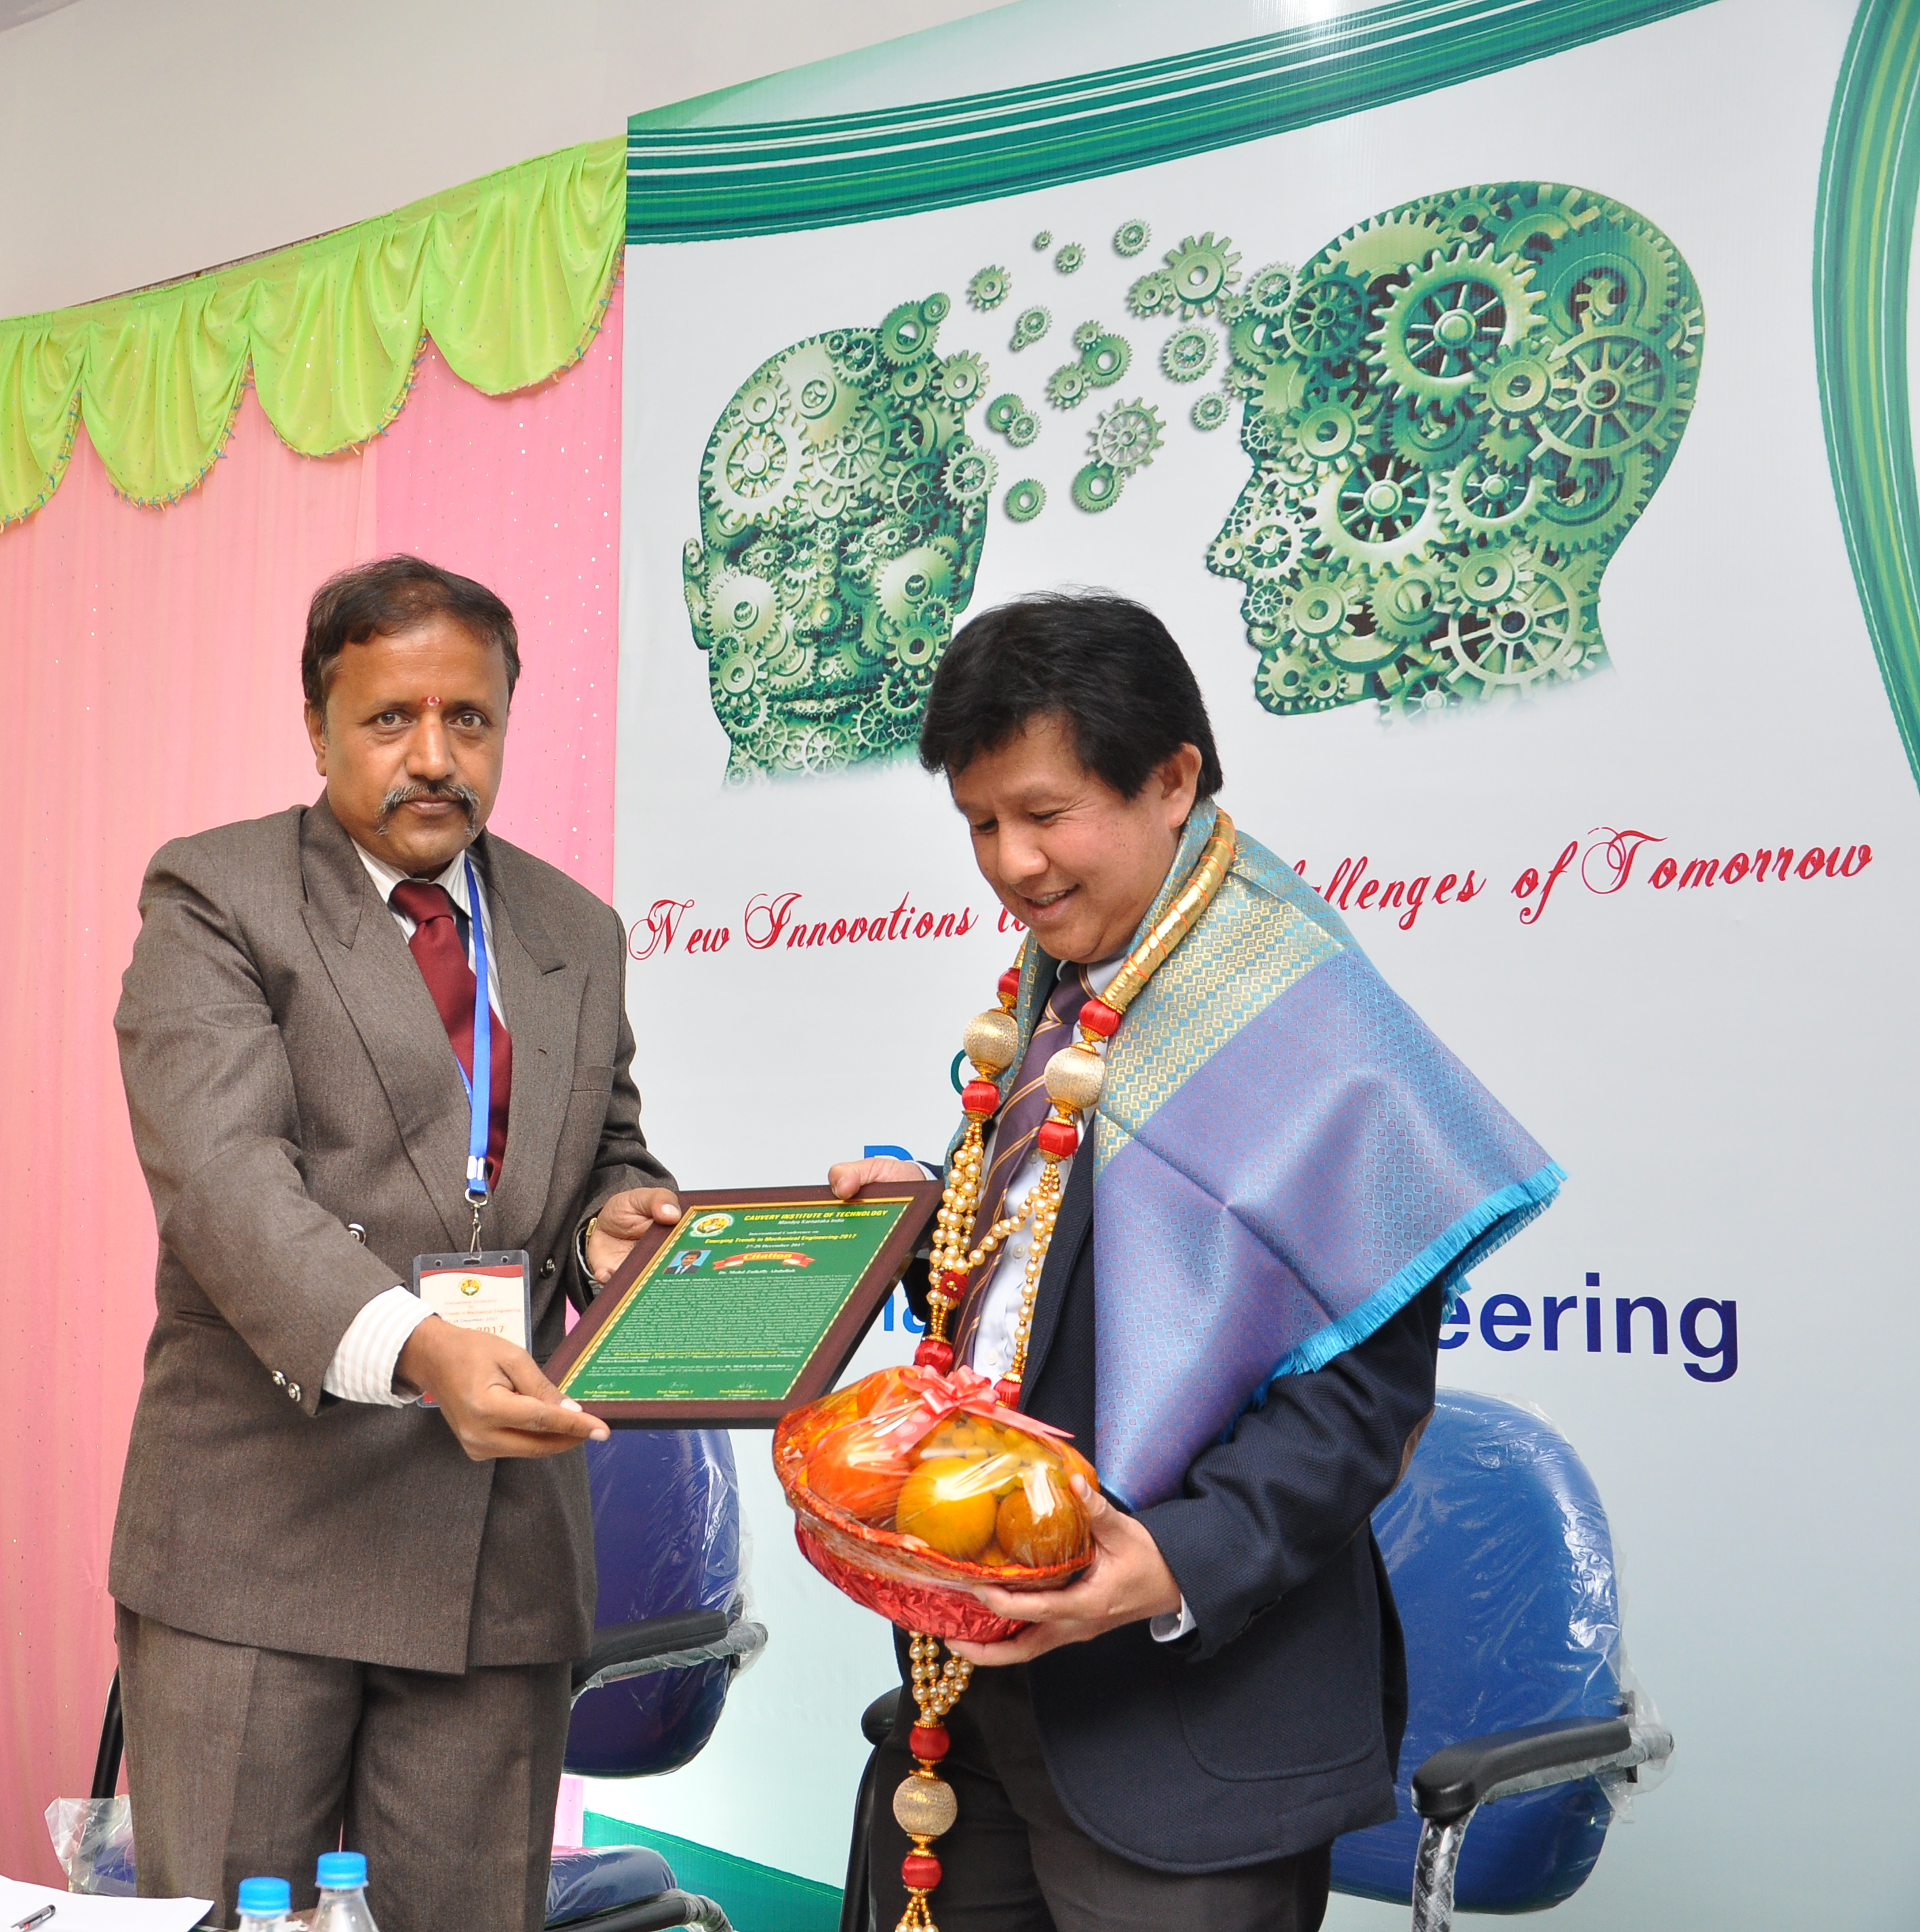
Prof. D Krishnegowda (President CERT) felicitating Dr. B G Sangameshwara (From Left); Prof. T Nagendra (Secretary CERT) felicitating Dr. Dong Wong Jung (Middle); Dr. Srikantappa A S (Principal – CIT) felicitating Dr. Md. Zulkifly Abdullah (From Right) during inaugural function during International Conference on ETME -2017
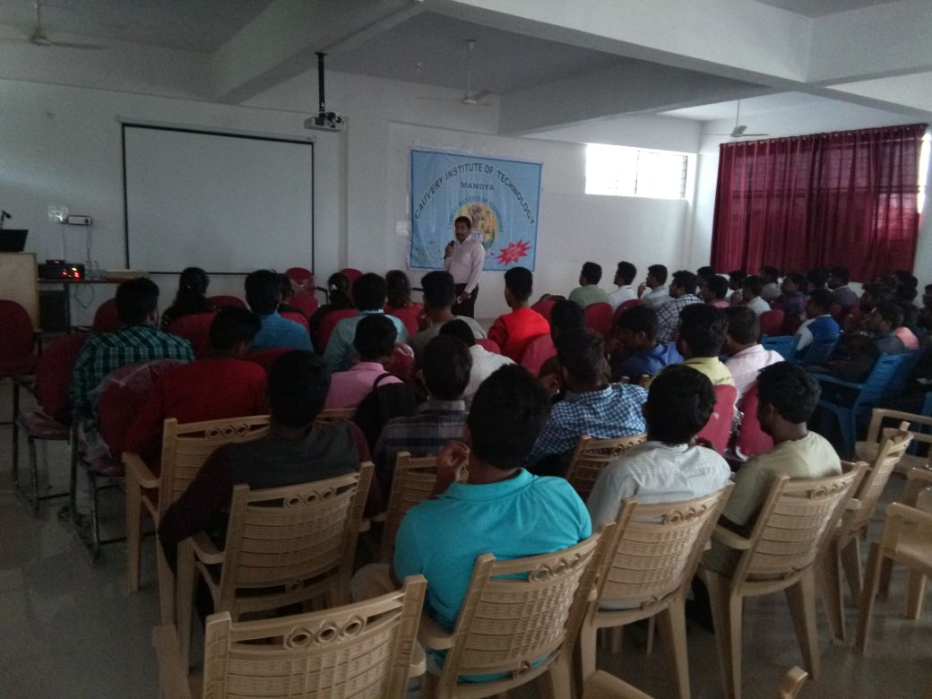
Talk on “Industry Expectations from Mechanical Engineering Students” by Mr.Prasannakumar Shankar MD & CEO, Maxpertise Technology Pvt. Ltd Bangalore
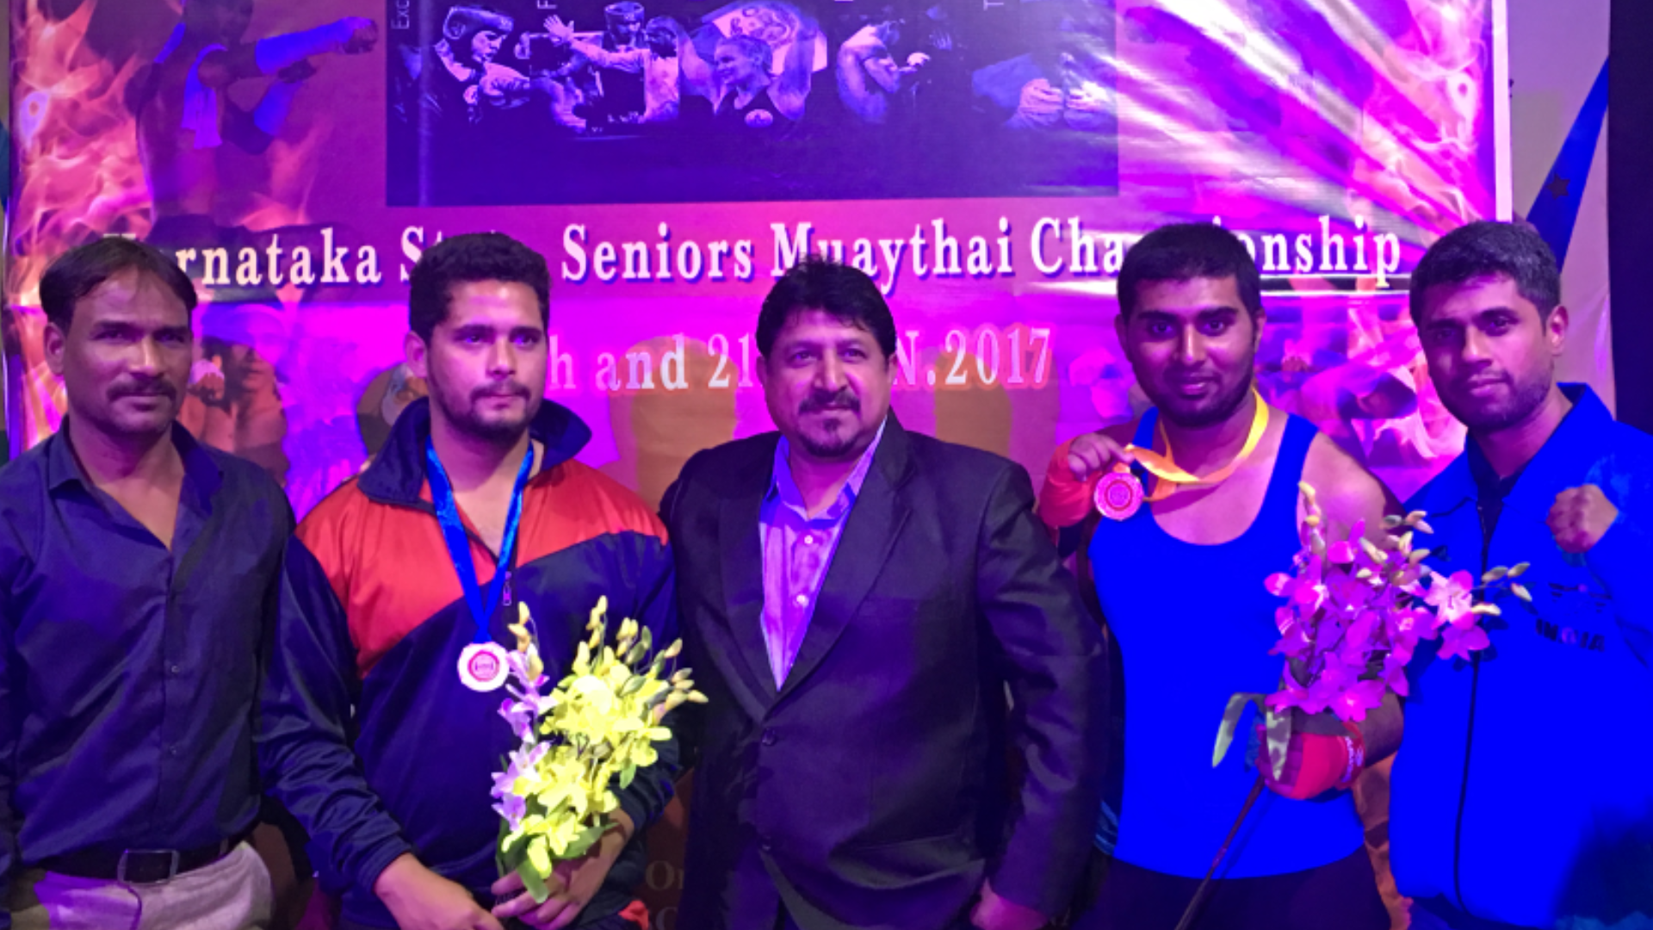
Faizan Ahmed Quraishi obtained Gold Medal in Muaythai Championship

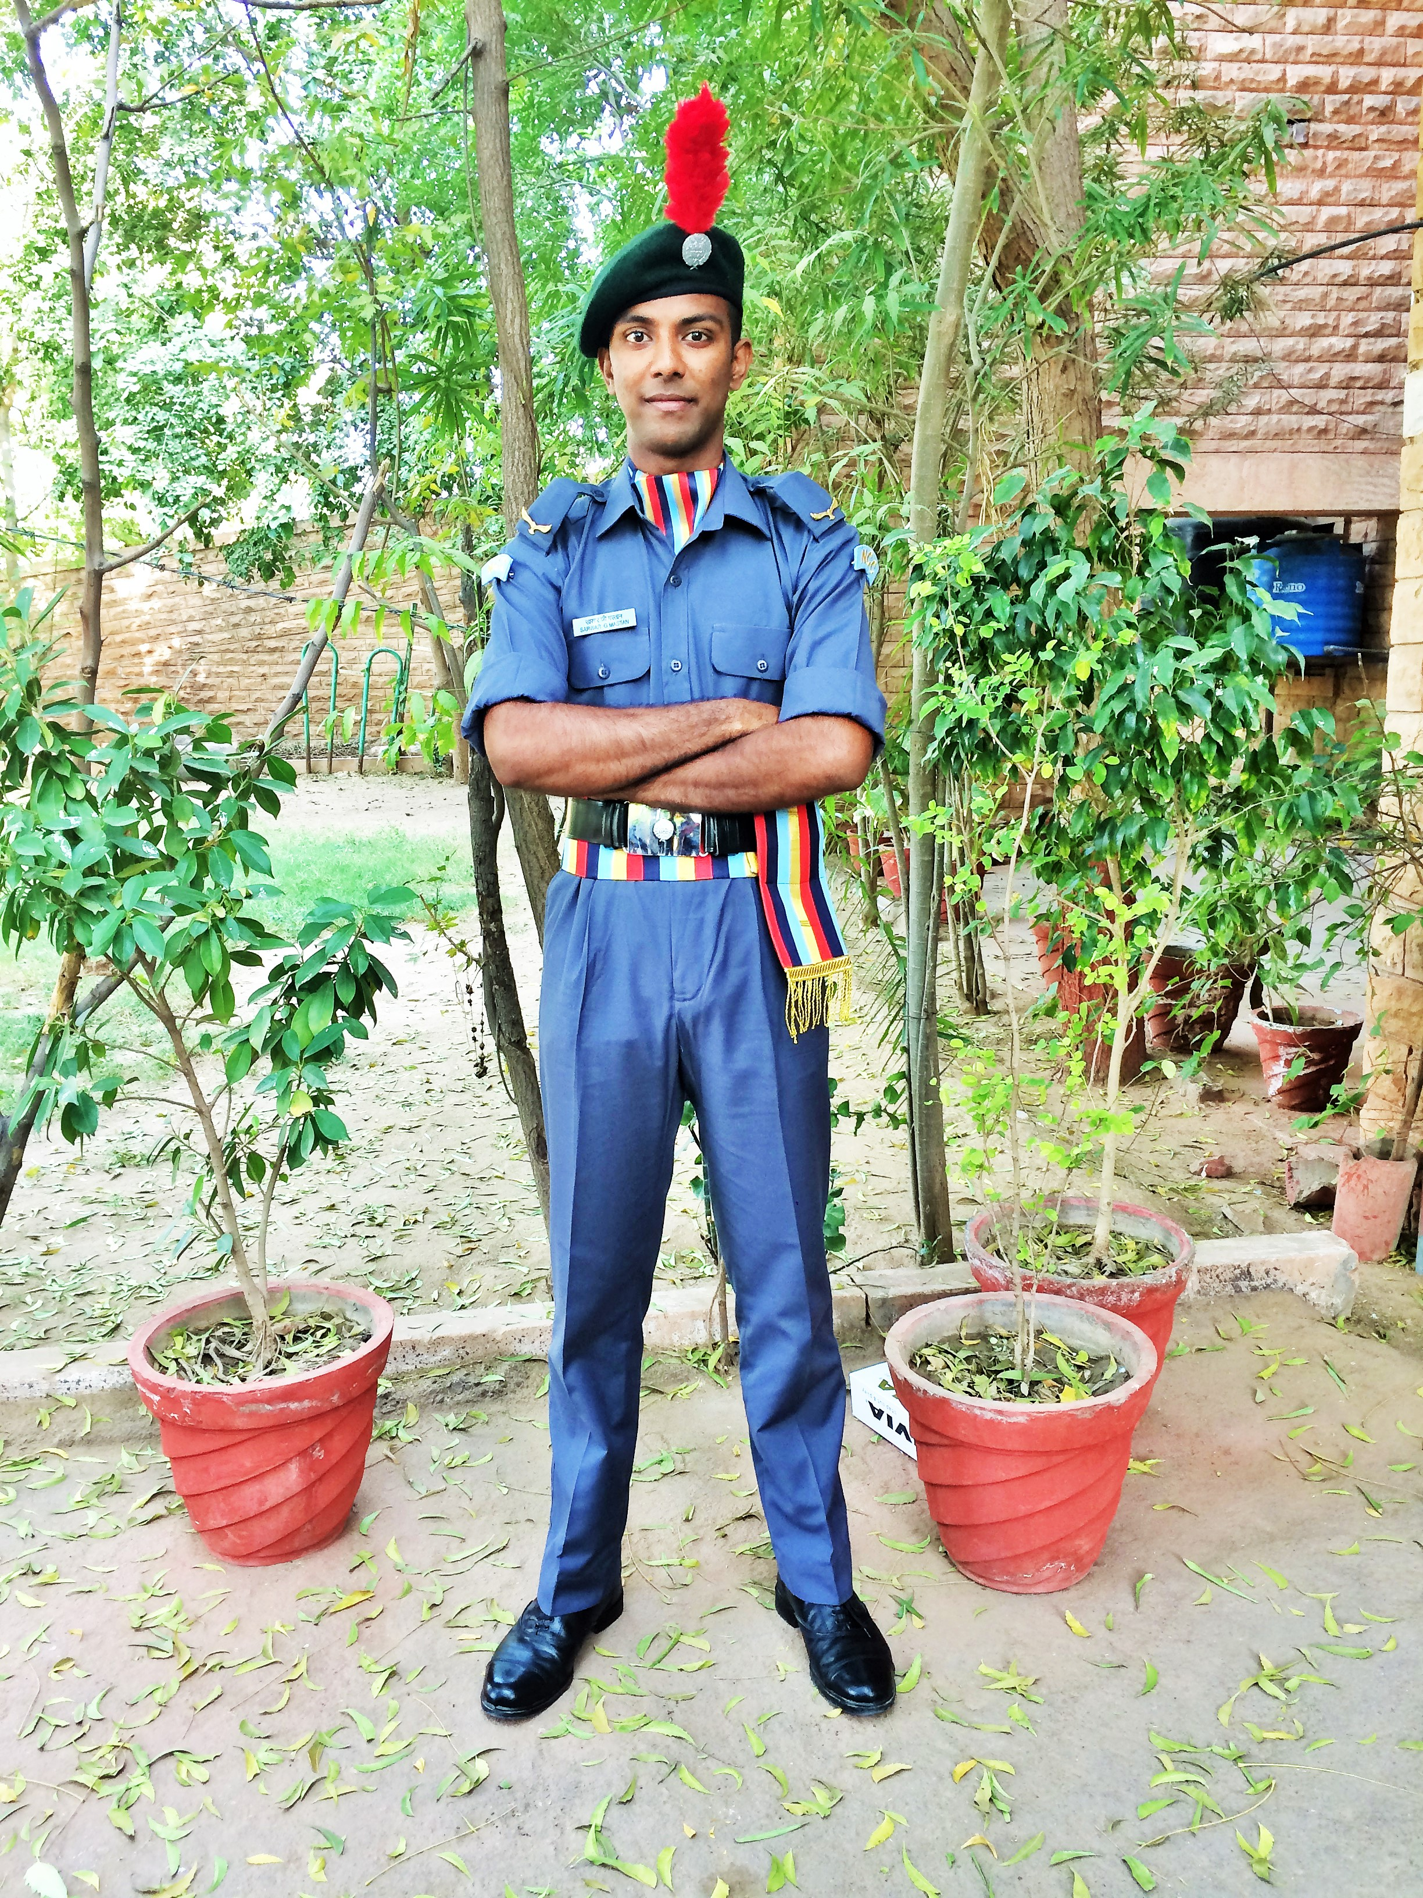
Sarwar Ghouse Mastan selected for National level NCC camp (left)
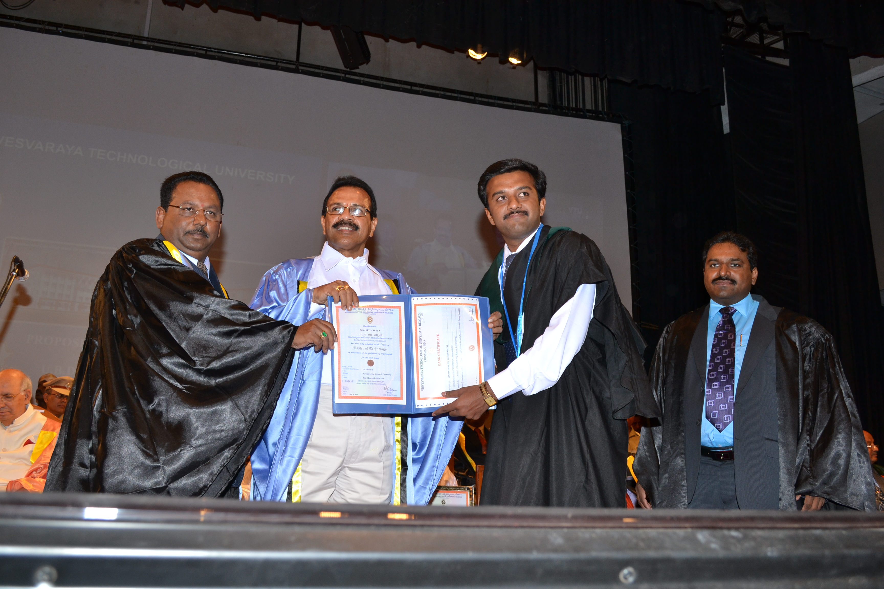
Prof. Maheshappa Former VC, VTU and Sadananda Gowda D V former Chief Minister
Karnataka, felicitating Dr.Vinaykumar M J

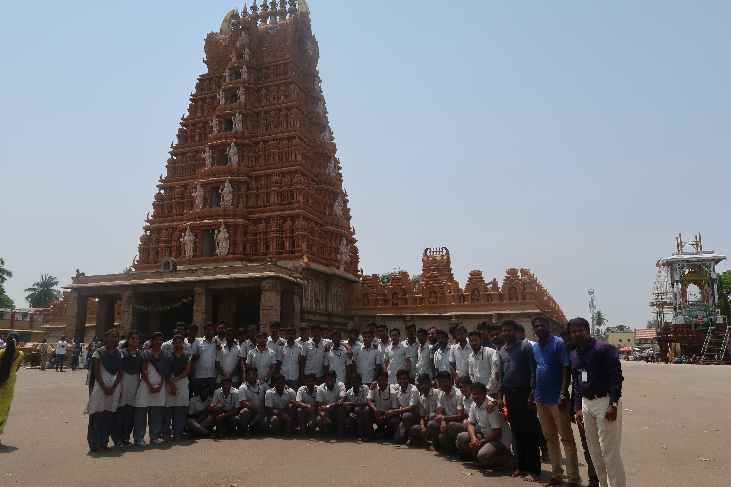
A Visit to Lord Nanjundeshwara Temple during the Industrial Visit for 8th Semester Students (2014 Batch)
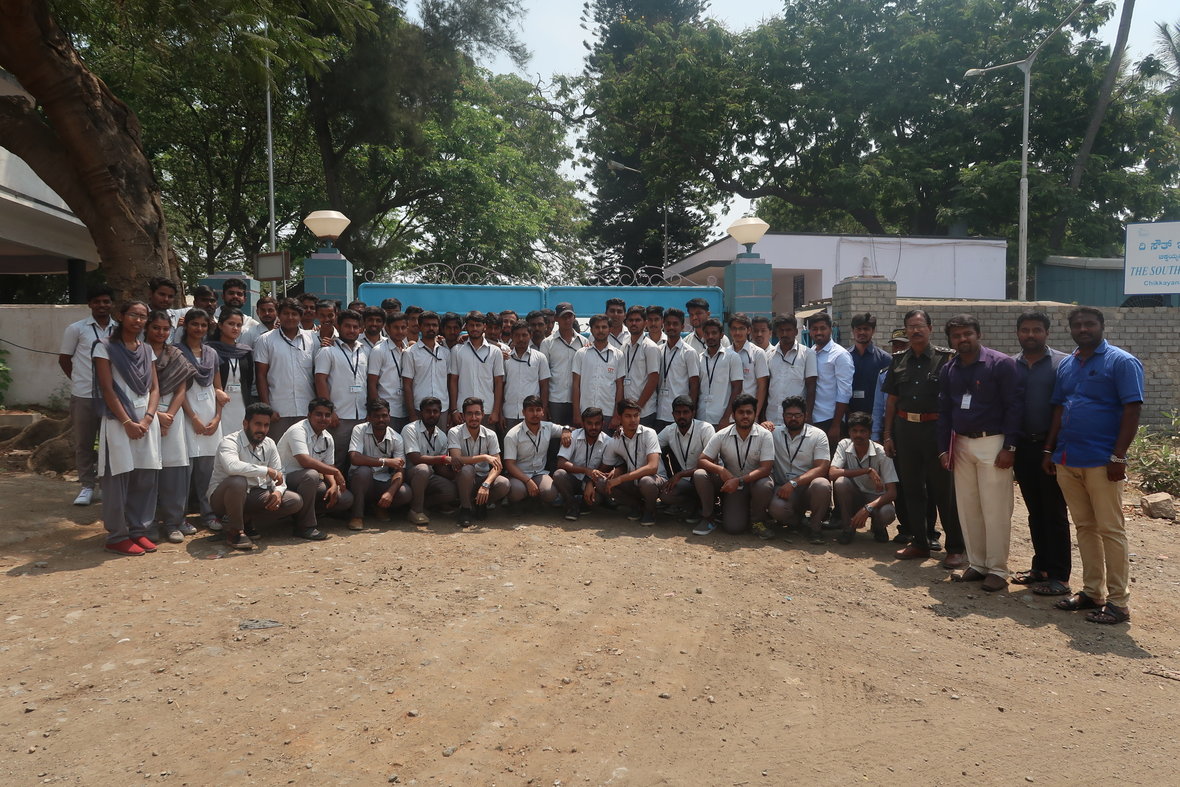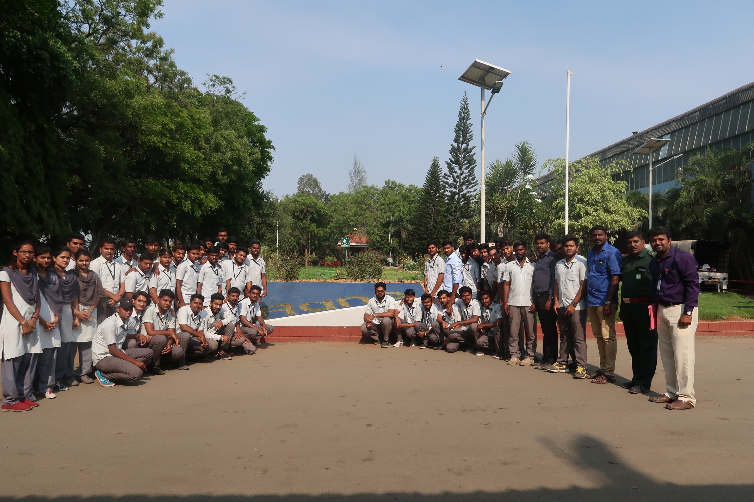
An Industrial Visit for the Mechanical Engineering Students (2014 Batch) to THE SOUTH INDIA PAPER MILLS LIMITED- A Paper Manufacture Division, Nanjanagud, Karnataka State and Rane (Madras) Limited Hebbal Industrial Area, Mysuru, Karnataka State on 10-03-2018

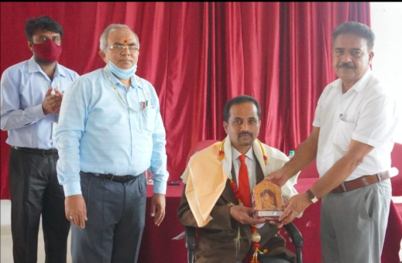
Prof. T Nagendra (Secretary CERT, Mandya) felicitating Dr. N Mohan Professor and HOD, Department of Industrial Engineering and Management during the “An International Webinar on –Fundamental Concepts of Tribology An Overview” Organised by Department of Mechanical Engineering
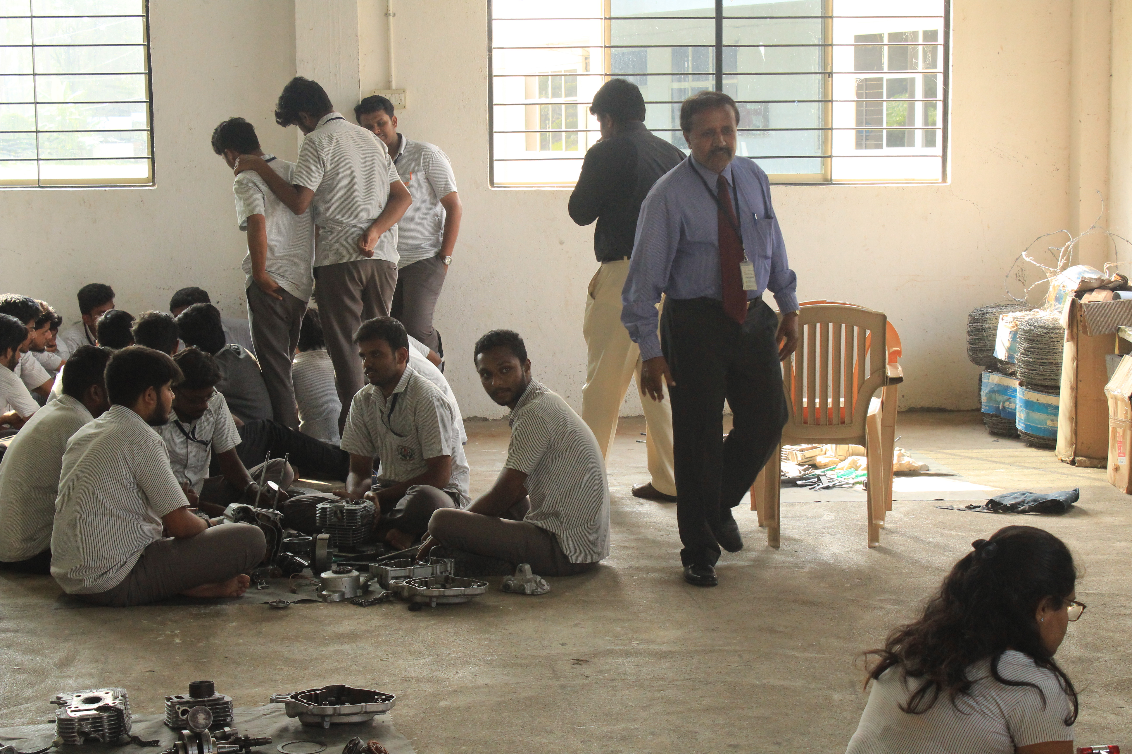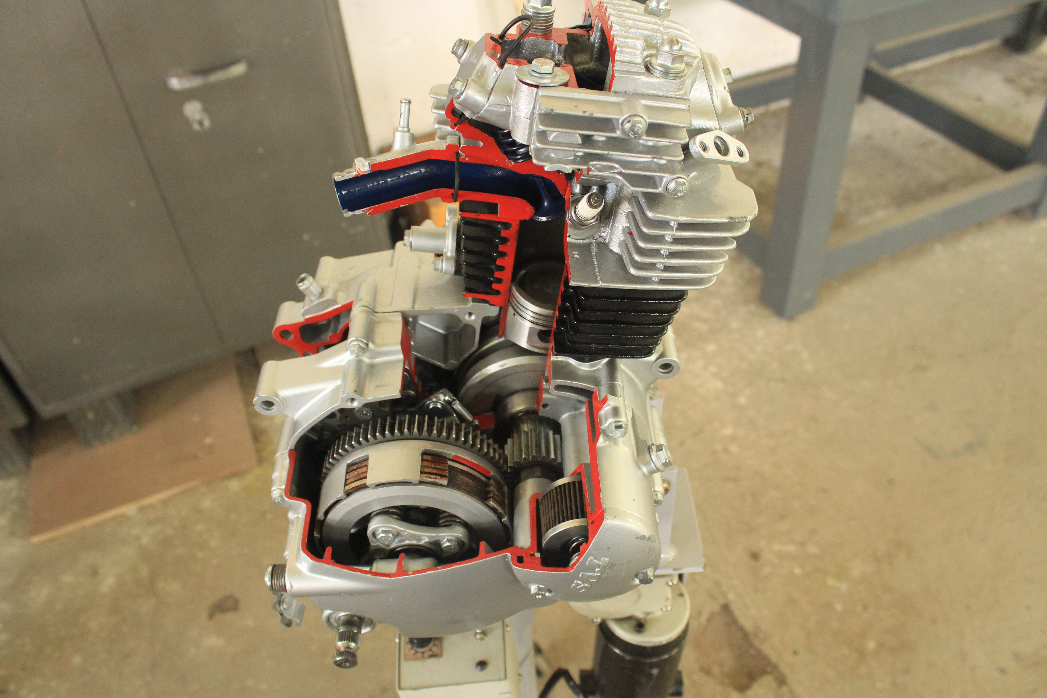
Department of Mechanical Engineering has Organized Two Days Workshop on Internal Combustion Engines in Association with A J Heuristic Bangalore 12th and 13th October 2018
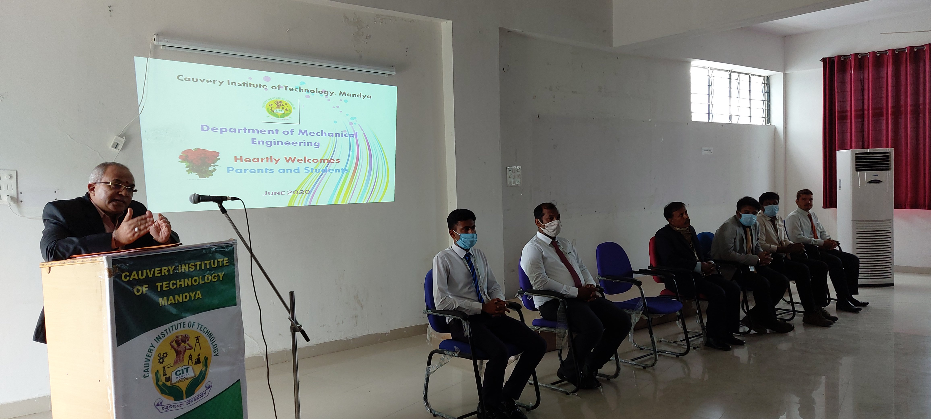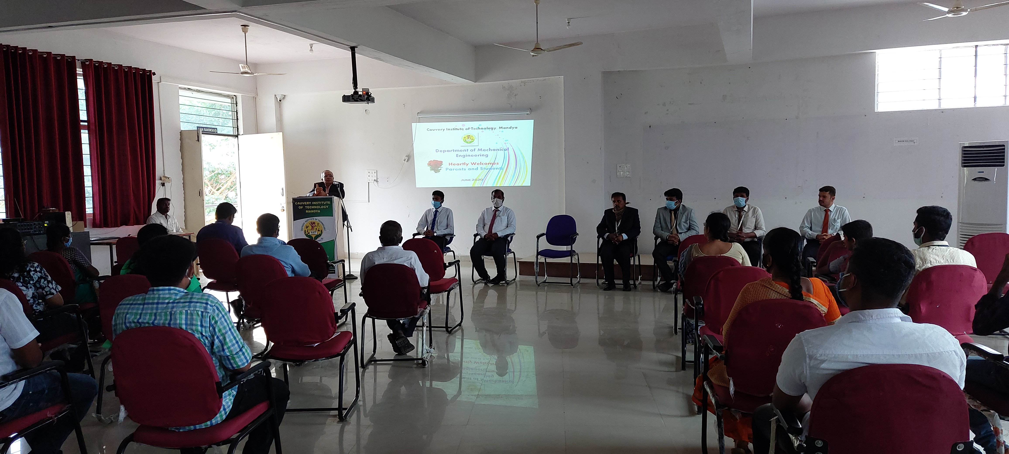
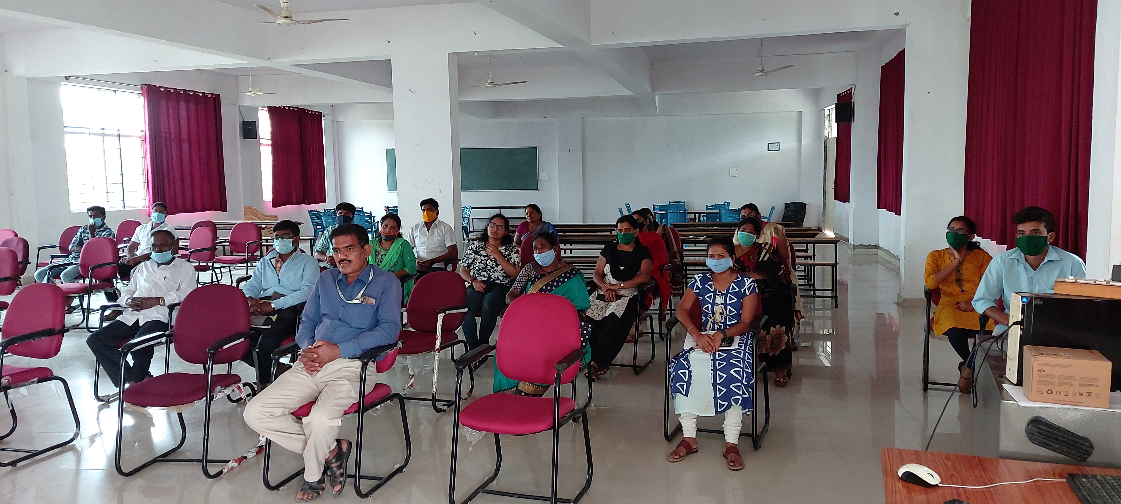
Department of Mechanical Engineering Conducted a Teachers –Parents Meeting at Cauvery Sabhangana in June 2020
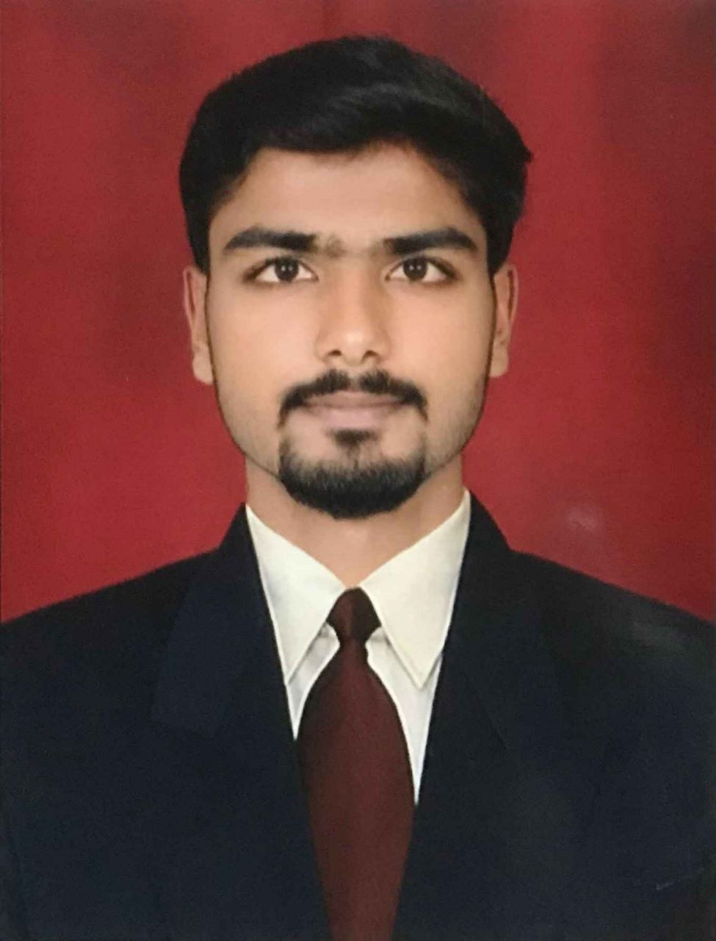
Mr. Vishwas Gowda P N (4CA18ME020) was successfully completed Student Exchange program as inbound student in the Mechanical Engineering Undergraduate Study Programmed, Faculty of Engineering, Universitas Tarumanagara, Jakartha during 2021/2022 even semester and obtained grade point of 4/4.

