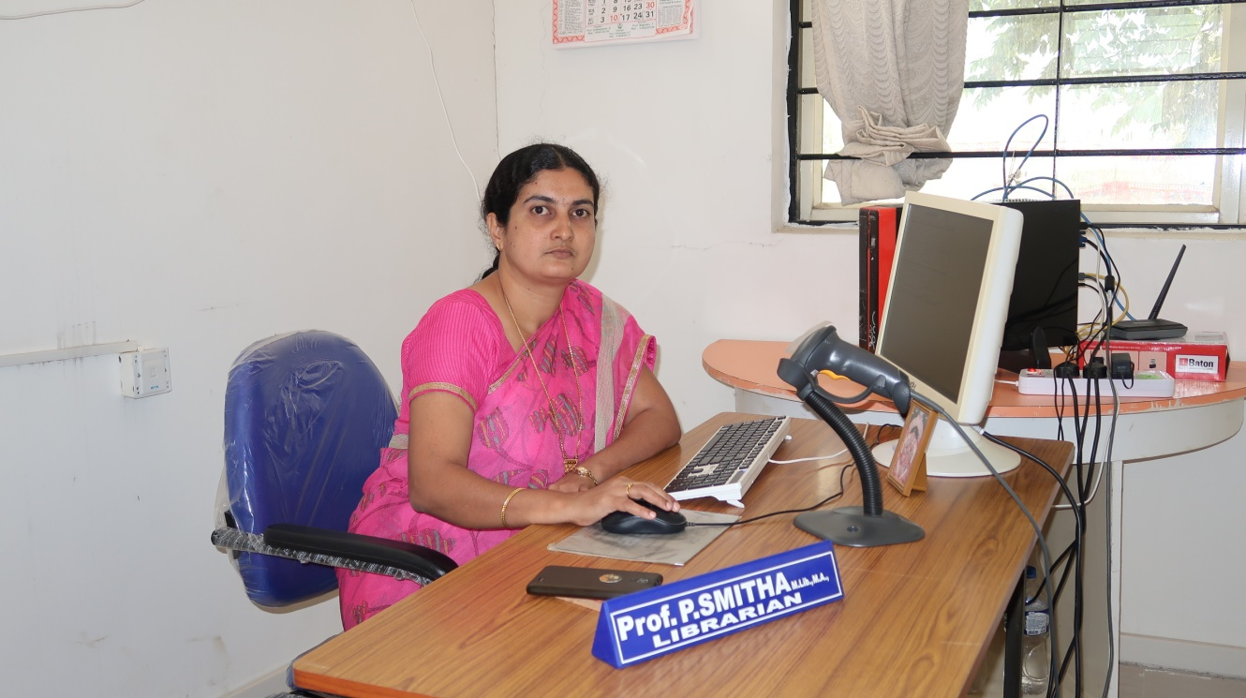
Name: Prof. P SMITHA _{M.Lib., M.A}
Designation: Librarian
Primary aim of the library is to support the curriculum needs of students, teaching staffs & support staffs of the institution through the development of pertinent collections. The provision of services designed to meet the user information and learning need such as Lending Service, Digital Library Service, and Periodical service. Library follows the open access system, encouraging the user to browse resources freely in the knowledge centre.

Vision
- To provide comprehensive resources and services to the researcher, teacher and students, meet their information needs to enrich their treasure of knowledge by providing the access round the clock-round the world.

Mission
- Acquires, organizes and preserves the resources.
- Consolidate and disseminate information to the intellectual community.
- Incorporate strong library ethics
- Effectively apply innovative tools and techniques for its continuous management and improvisation.
Automated Library: ed Library
Library uses Easily-Integrated Automation Software, which supports in-house operations of library such as acquisition, cataloguing, circulation, serials control and OPAC. Database is updated daily.
Smart circulation system is used successfully via Bar-code technology for all the resources and barrower cards.

Services:
- Lending: Stack books will be issued to the students for defined days. Books so lent shall be returned on due date. The same book can be reissued for another 15 days if it is not in demand. [Lending books are spine labeled with white colour for identification] An overdue charge of Rs.1/- per day will be charged if a book is kept beyond the date.
- Reference: Reference books will also be issued to the users for defined days. Books so lent shall be returned on due date. The same book can be reissued if it is not in demand. [Reference books are spine labeled with red colour for identification]
- Digital Library: LIC provides the internet connected computer systems to access the E-Databases, E- Journals, E-Books, other subscribed e- resources and internet browsing for students and staff community.
Statistics
Sl.No | Particulars | Stack
1 | Number of Volumes | 6500
2 | Number of Titles | 1250
3 | Books Lending Privileges | 5 Books for students & 10 Books for Staff
4 | Print Journals | 12
5 | Question Papers | Hard & Soft Copy Available
6 | Magazines | 12
7 | Newspapers | 05
8 | Digital Library | Server : 1 (for Institutional Repository)  Clients : 10 , internet & LAN  connected system
9 | Seating capacity | 70
10 | Dimension of the Library | 2300sq.mtr.
11 | Library Management Software | Easylib : Integrated Library Automation software Circulation- implemented with Barcode Technology  Issue & Return : implemented barcode reader
12 | OPAC (Online Public Access Catalogue) | Server – 1, Clients – 4
 |  | Circulation- Issue & Return : implemented barcode reader
 |  | Exclusive systems to search library holding
13 | Reprographic Machine | 1 Multifunctional Machine (Print/Scan/ Photocopy)  For reprographic facility.

E-Resource Subscription Access: MITM is member of VTU Consortium, through the consortium library provides the access to subscribed E-Content (e-journals/e-books/Etc.) and Technology Platforms (Plagiarism / Grammar / Remote Access Tools/Etc.)
Periodical:
- E-Journals: Library provides the thousands of E – journals access related to science, engineering and management disciplines subscribed under the membership of VTU Consortium.
- Print-Journals: Library currently subscribed the print journals related to various disciplines to staff and students for teaching and research oriented programs.
- Magazines/Newspapers: Library provides the subjective & general magazines and daily news papers.
- OPAC (Online Public Access Catalogue):
OPAC (library catalogue) allows the users to search the library holding such as books and other materials. It will help principally to locate books and other material available in the library. The library catalogue is searched by author, title, and keyword.
- QUESTION PAPER:
The library facilitates to access the previous year’s exam question paper in electronic format available in our institute website as well as in the MITM Institutional Repository for reference purpose to the patrons.
- ID card:
Library provides the instant ID card printing service to the college community. It serves as college Identity Card and Library Borrower Card.
- Digital Library:
Digital library equipped with LAN connected computer system with 15 and internet connection with intense to offer the following services to the user community.

A. To access the online course materials and resources such as;
- MOOC courses lecture videos such as SWAYAM
- NPTEL online academic content along with MOOC materials
- Open Courseware materials such CIT open courseware and VTU E-Learning materials B.E for technical presentation, project and research work.
- REPROGRAPHIC SERVICES
Reprographic service facilities are exclusively meant for registered users of LIC and only for library study materials.
Reprographic facilities:
- Photocopy
- Print
- Document Scan
INTERNET
The Institution has enabled adequate internet facility to support the operations. The details of internet provider and the specifications are provided in the following.
Details of Internet availability
1 | Name of the Internet Provider | BSNL Broad Band
2 | Availability of Bandwidth | 500 Mbps
3 | Wi-Fi availability | Yes
4 | Internet Access in Lab Classrooms, Library and offices of all Departments | Yes

Rules and Regulations
Code of Conduct

The CIT Library endeavors to provide a friendly space and environment for information and knowledge exchange. The Library Code of Conduct is established to ensure that this environment is maintained.
Users: Code of Conduct applies to all areas of the CIT Library, including Stack Area, Reference & Periodical Section, Study Spaces, General Reading Room and Digital Library. Library users must nurture the following guidelines below.
- Personal belongings including bag and personal text books will not be allowed inside the stack and reference area except loose sheets and notebook.
- Reading materials including notebooks, personal textbooks will be allowed inside the general reading room only.
- Bags, cases, folders etc. must be left in the property counter.
- Users are advised not to leave their valuable items such as wallet, laptops debit/credit card etc., at the property counter. Library is not responsible for any loss of individual’s aforesaid properties.
- Users are required to enter their USN/Member ID and sign the register provided at the entrance.
- Students’ Institute Identity Card is necessary for access to the library and information centre.
- The users shall maintain silence within the library premises..
- Use of mobile phones is strictly prohibited.
- Library authority upholds the right to recall any issued book even before the due date.
- Anyone caught marking, defacing or mutilating books or any other library material is accountable to replace the same.
- The membership of the library is not transferable.
- Users are not allowed to reshelf books or journals after removing them from the shelf. Leave them on the table or on the nearby trolley.
- Eatables are not allowed inside the Library.
- If the mentioned codes of conduct/rules are not honored the user, then The Library has the right to expel a user from the premise.
- Borrowers are to produce their ID card when borrowing resource materials.
- ID cards are not transferable. Use of ID card is restricted to user to whom the card is issued.
- Members must satisfy themselves about physical conditions of the library material being issued. They shall be held responsible for any damage/mutilation noticed at the time of return.
Loss of Books
- When an item is lost or damaged, the borrower will be charged for the item as follows.
- The member has to procure a new edition copy of the same with processing fee of Rs.50/- per book and overdue fines if any. Or
- A sum of three times the estimated cost of an item will be charged for loss of book / item.
ISSUE OF NO DUE CERTIFICATE
Library No-Due certificate will be issued to the users after the return of borrowed library resource materials.
Students:
- Students have to produce their ID-card at the time of getting No-Due from the library.
- Students who are discontinuing/ leaving the college have to surrender their ID-Card to get the No-Due from the library.
Staff Members/Research scholars:
Staff members have to surrender their ID-Card to get the No-Due from the library while leaving the Job

ID CARD / LIBRARY CARDS.
The Institution ID card is the member identification and key to accessing facilities and services . The Institution ID card is issued to students, staffs and research scholars of the institution.
The Institution ID card will serve as:
- Your Identity Card
- Your Library card
- Access card to campus facilities and services.
E – Resources
VTU Consortium

“Following databases can be accessible in any LAN connected systems in the campus. E –Journals
- Springer Nature ( ME/ECE/CV/CS/BS/ENG)
- Elsevier ( CS/ME/ECE/CV/ENG)
- Taylor & Francis ( CS/ME/CV/ENG)
- Emerald (MGT)
- ProQuest (Engg./MGT)
- IEEE (POP) (CSE/ISE/EC/MCA).

E-Databases:
Sl.No | Name of the e-databases | URL’s
1. | Elsevier | www.sciencedirect.com
2. | Springer Nature | https://link.springer.com/
3. | Taylor & Francis | https://www.tandfonline.com/
4. | Emerald | https://www.emeraldinsight.com/
5. | McGraw Hill Education | http://mcgrawhilleducation.pdn.ipublishcentral.com/
6. | New Age International | http://www.newagepublishers.com/servlet/nahome
7. | Packt | https://prod.packtpub.com/in/
8. | Knimbus | https://new.knimbus.com
9. | Turnitin | https://www.turnitin.com/

